Stub AS

🌐 What Is Stub AS?
# Source: Chatgpt (GPT‑5 Mini) at [12/15/2025]
A Stub AS is an Autonomous System that is connected to only one other AS and does not provide transit for any other network. It sends and receives traffic only for its own internal network — not for others.

🧠 Simple Definition:
# Source: Chatgpt (GPT‑5 Mini) at [12/15/2025]
A Stub AS is a small network that connects to just one ISP and only handles its own traffic — not a middleman.

🔁 Key Characteristics
# Source: Chatgpt (GPT‑5 Mini) at [12/15/2025]
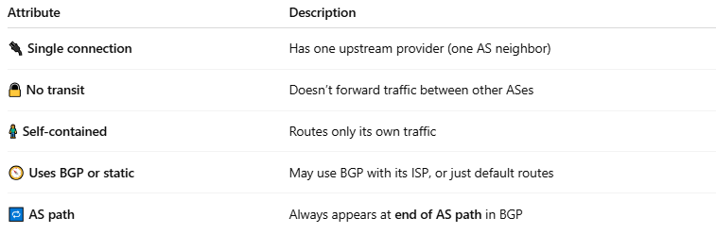

Attribute | Description
🔌 Single connection | Has one upstream provider (one AS neighbor)
🔒 No transit | Doesn’t forward traffic between other ASes
🧍 Self-contained | Routes only its own traffic
🧭 Uses BGP or static | May use BGP with its ISP, or just default routes
🔁 AS path | Always appears at end of AS path in BGP

📦 Real-World Example
# Source: Chatgpt (GPT‑5 Mini) at [12/15/2025]
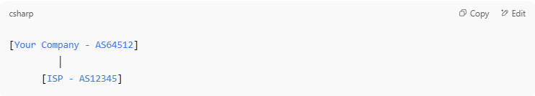
[Your Company - AS64512]
│
[ISP - AS12345]

- AS64512 is a stub AS — it only sends/receives its own data through the ISP.
- It does not carry other people's traffic.

📶 Stub AS vs Transit AS vs Multihomed AS
# Source: Chatgpt (GPT‑5 Mini) at [12/15/2025]
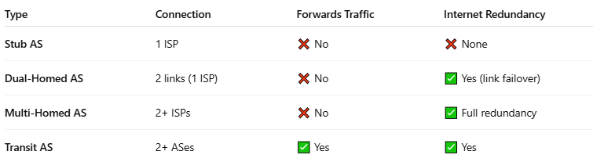

Type | Connection | Forwards Traffic | Internet Redundancy
Stub AS | 1 ISP | ❌ No | ❌ None
Dual-Homed AS | 2 links (1 ISP) | ❌ No | ✅ Yes (link failover)
Multi-Homed AS | 2+ ISPs | ❌ No | ✅ Full redundancy
Transit AS | 2+ ASes | ✅ Yes | ✅ Yes

✅ Summary
# Source: Chatgpt (GPT‑5 Mini) at [12/15/2025]
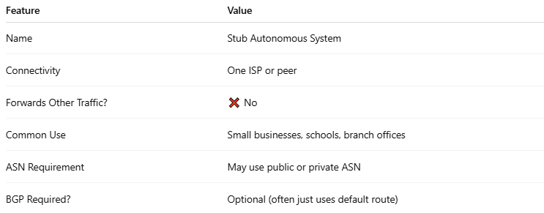

Feature | Value
Name | Stub Autonomous System
Connectivity | One ISP or peer
Forwards Other Traffic? | ❌ No
Common Use | Small businesses, schools, branch offices
ASN Requirement | May use public or private ASN
BGP Required? | Optional (often just uses default route)

